LAB REPORT

(Names) Bryon Ferrer, Sajana Wijesinghe
(Date) 11/29/18

Title: Lab Number 9
Statement of the Problem:

The question we are trying to answer in this lab session is “How can we use Arduino hardware and software to control the Servo’s position?” This pertains a lot to robotic programming, as a servomotor serves as the control for the robot arm to accomplish specific tasks. For instance, a servomotor can be used in civilian and military drones to position a flight control surface. This lab requires the use of the “attach” method from Arduino’s <Servo.h> library in order to make a Servo object use a Pulse Width Modulation output pin number, which is generated by a +5 or 0 volt level but can change very fast. This can be a method to make outputs acting as analog outputs from digital outputs. The class also includes a “write” method that takes an integer value between 0 and 180 that corresponds to the arm’s position in a semicircular arc and sets the duty cycle of the pin to the corresponding effective analog voltage. We then use the math library function “map” to scale the value to a value to be written by the servo. Then, we use real analog input to control it’s position by connecting a potentiometer across +5 volts and ground and connecting the center tap wire to the analog input pin A0 in the microprocessor. Using the library analogRead, we read the integer value from 0 to 1023 that corresponds to the voltage/position of the knob/shaft on the pot, which is determined from the center tap controlled by the position of the knob or shaft and it’s corresponding voltage value.

Materials:
- USB Cable
- Arduino Uno microprocessor
- Parallax 4-6 VDC Standard Servo

Procedure:
- As usual the first step is to set up the circuit properly. The picture below is what your setup is supposed to look like when its complete
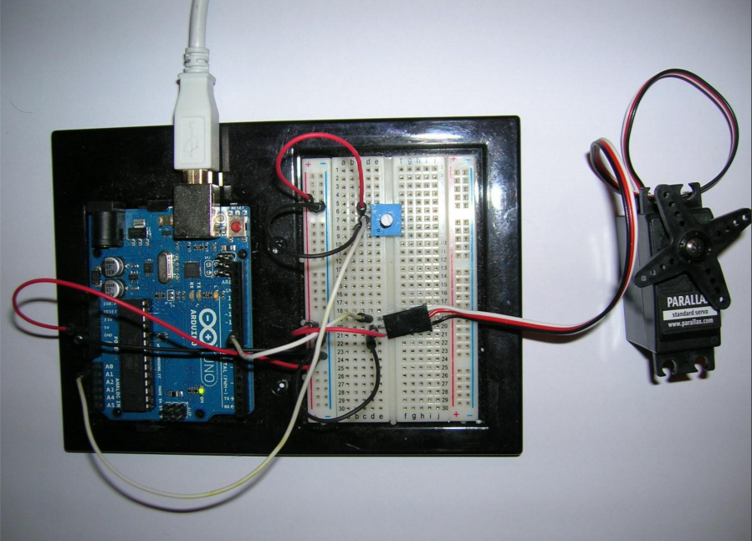

- Once its complete, connect it to the PC using the USB Cable
- The appearance of a light on the board means that the setup was properly built and that the current is flowing.
- Next you’ll have to input a code into the Arduino.exe program
- The code is as follows:

#include <Servo.h>

Servo myServo;

int potpin = 0;
int val;

void setup() {
myServo.attach(9);
}

void loop() {
val = analogRead(potpin);
val = map(val, 0, 1023, 0, 180);
myServo.write(val);
delay(15);
}

- Once that’s done, compile and run it.
- Now you should be able to use the Arduino Uno microprocessor to control the Parallax 4-6 VDC Standard Servo

Conclusions:

There are a couple of things I learned from the lab. First, I learned more about analogRead() and another way it can be used in a situation involving more advanced concepts such as robotics. I also learned about the field of robotics and how software and hardware can be connected to each other in fields like it when concepts are married to them, such as voltage and programming in C. Third, I learned more about servos, robotic arms, and their applications in real life and how we can use programming skills to build the foundations for how these devices work.

Code:

#include <Servo.h>

Servo myServo;

int potpin = 0;
int val;

void setup() {
myServo.attach(9);
}

void loop() {
val = analogRead(potpin);
val = map(val, 0, 1023, 0, 180);
myServo.write(val);
delay(15);
}

